

**Chandpur Science and Technology University**

## Department of Computer Science and Engineering

**LAB ASSIGNMENT #3**

**C Lab Assignment Submitted By:**

**Name: Iftekhar Hossain**

**Student ID: B220101024**

**Submitted To:**

**Prince Mahmud**

**Lecturer**

**Department of Computer Science and Engineering, CSTU**

Marks & Signature

|  |
| --- |
|  |

Lab Date:

Submission Date: 10/12/2023

**Problem No – 1**

Write a program to input two integer numbers and display the sum of even numbers between these two input numbers.

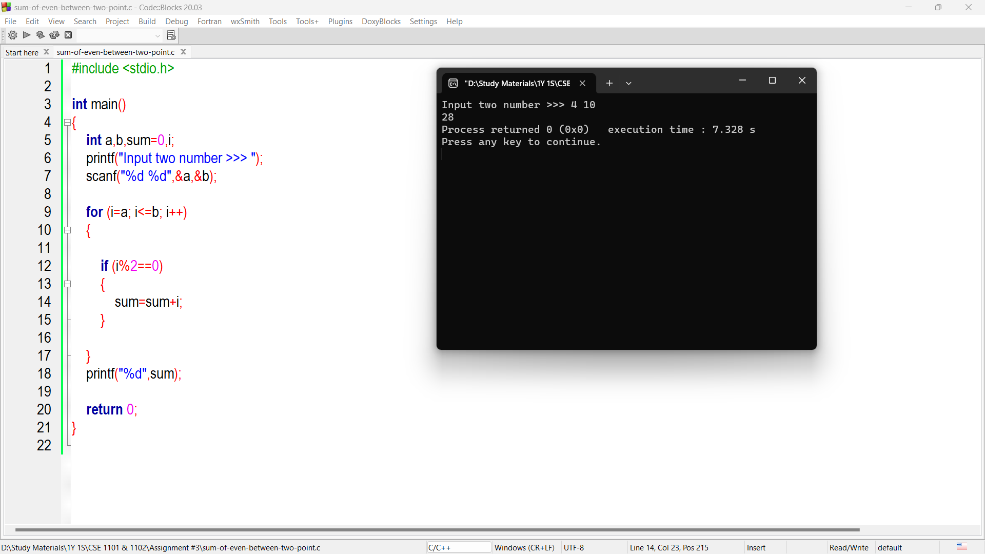

**Problem No – 2**

Write a program to find GCD (greates common divisor or HCF) and LCM (least common multiple) of two numbers.

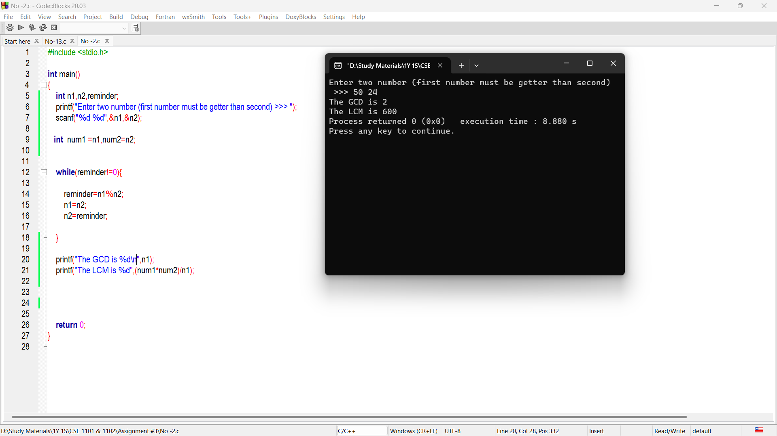

**Problem No – 3**

Write a program to print the Fibonacci series up to n terms where n is user input.

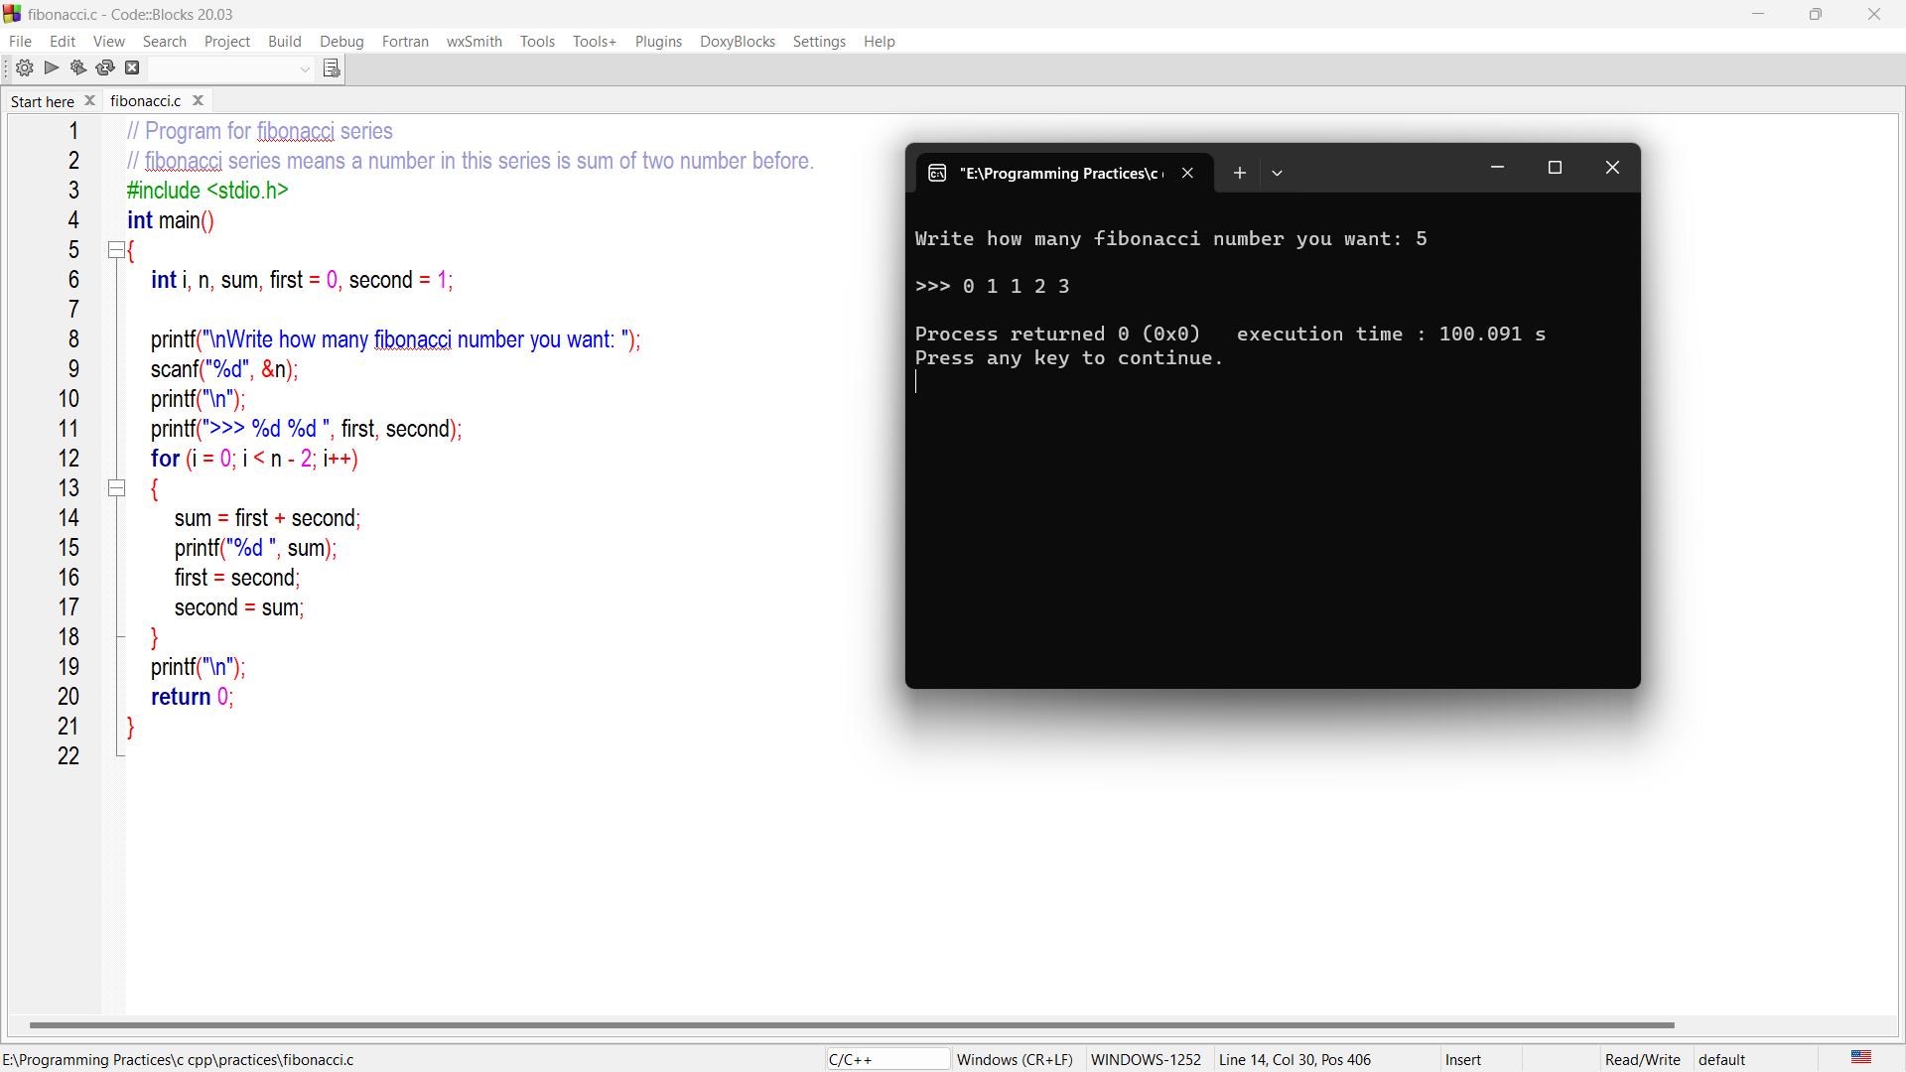

**Problem No – 4**

Write a program to determine all prime numbers within the range [a ...b] where a & b are user input.

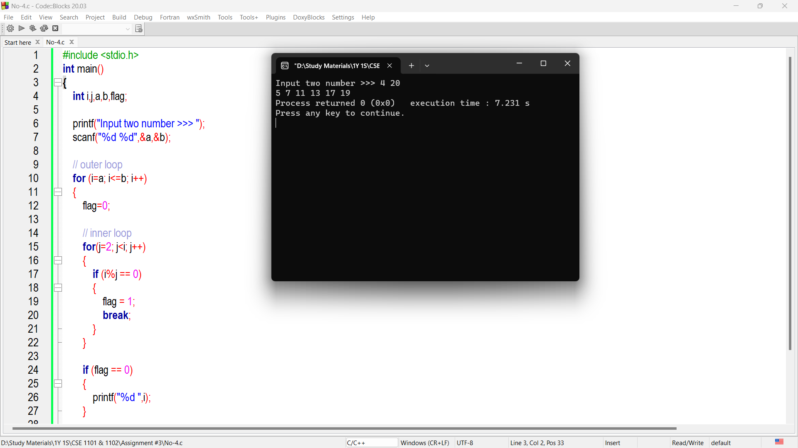

**Problem No – 5**

Write a program to find, first using a ‘while’ loop and then a ‘for’ loop, the sum of first n terms (n >= 1) of the series 2x3, 3x4, 4x5, …, (n+1)x(n+2). You need to verify that you get the same result in both the cases.

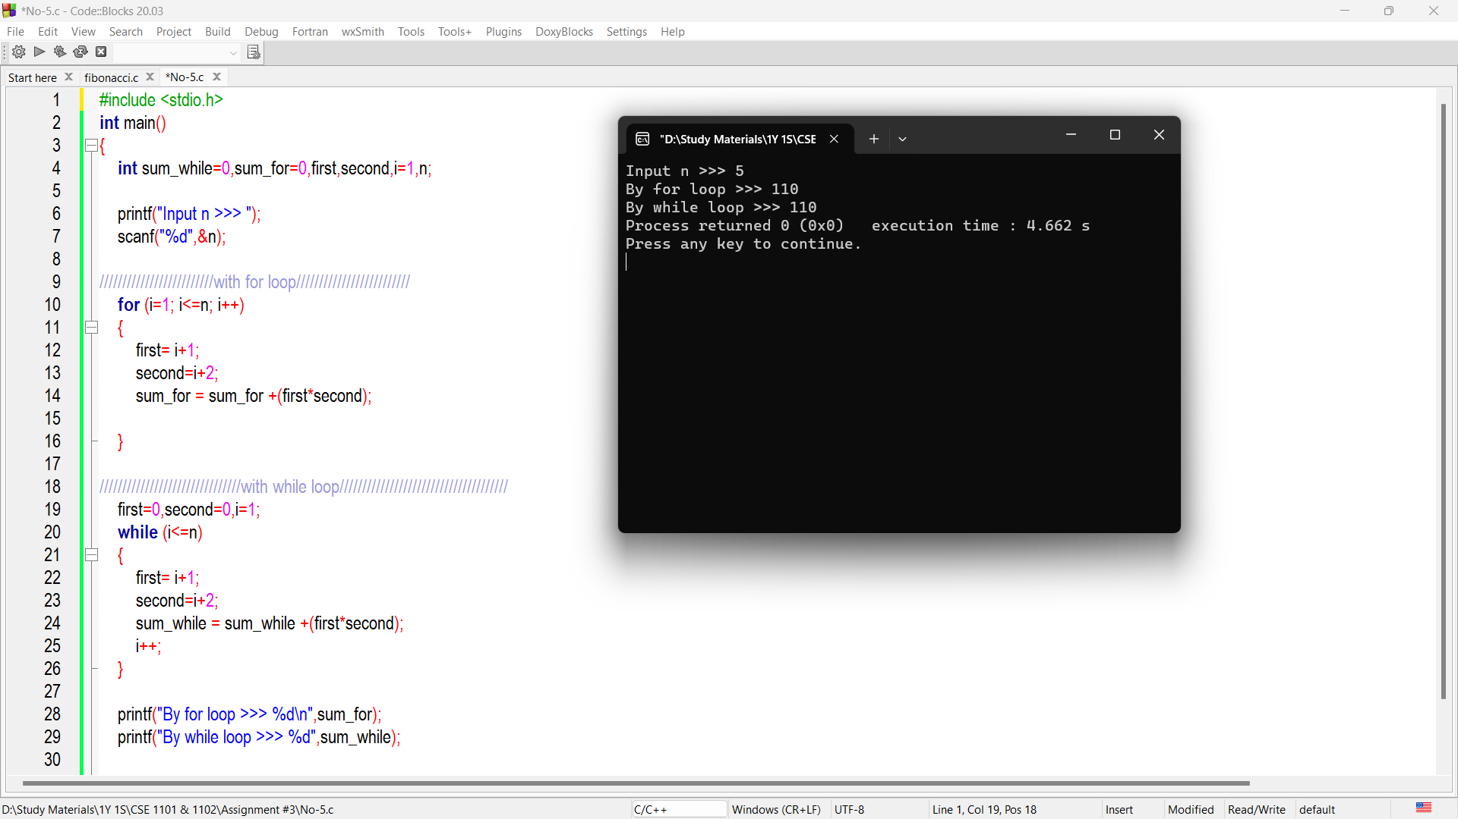

**Problem No – 6**

Write a program to check whether a given integer is palindrome or not. [*121 is palindrome but 123 is not*]

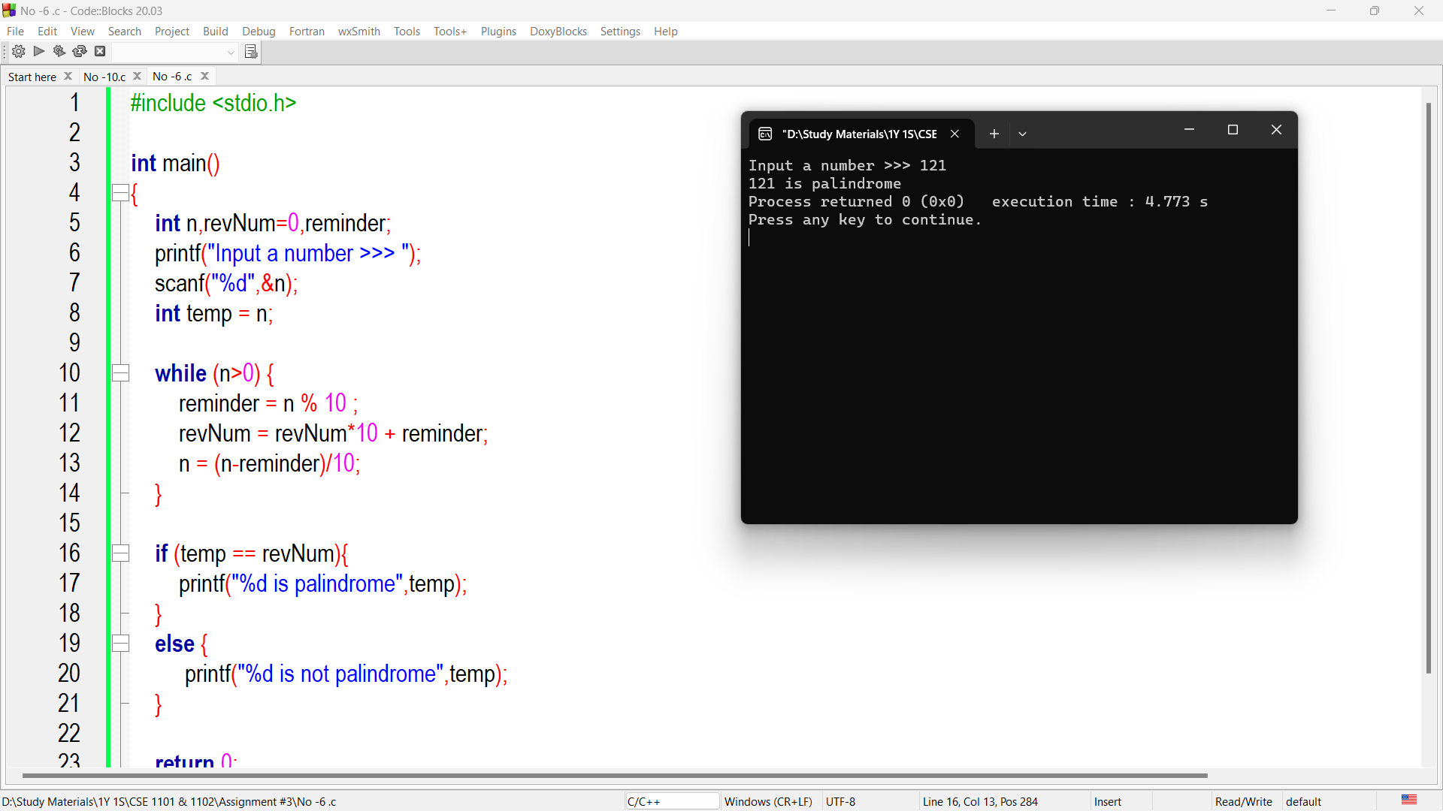

**Problem No – 7**

Write a program to print out all Armstrong numbers between 1 and 10000. [Example, 153 = (1*1*1) + (5*5*5) + (3*3*3)].

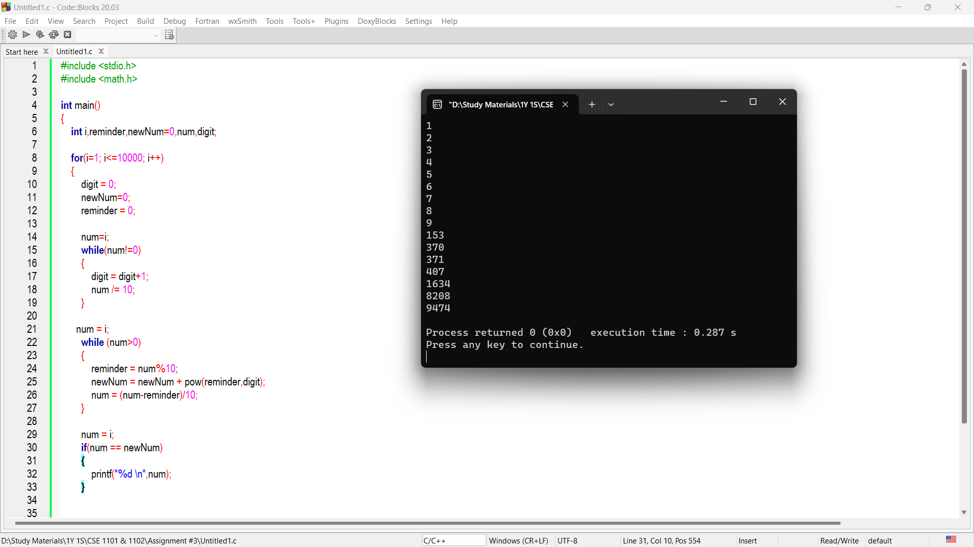

**Problem No – 8**

Write a program to reverse a given number using while loop.

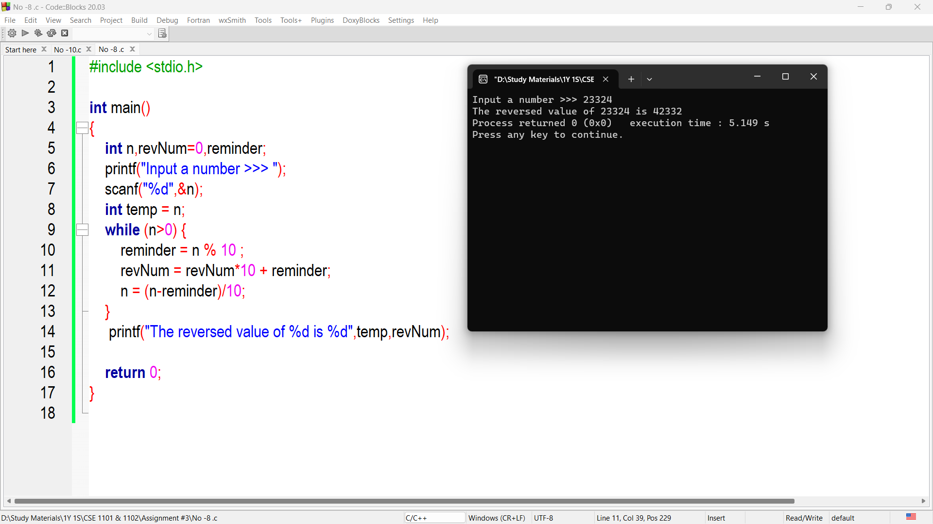

**Problem No – 9**

Write a program to find a grade of given marks using switch case statement.

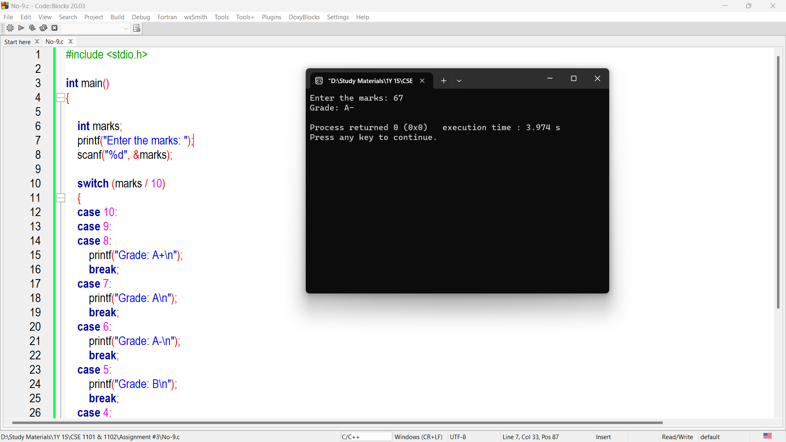

**Problem No – 10**

Write a program in C to display the multiplication table for a given integer.

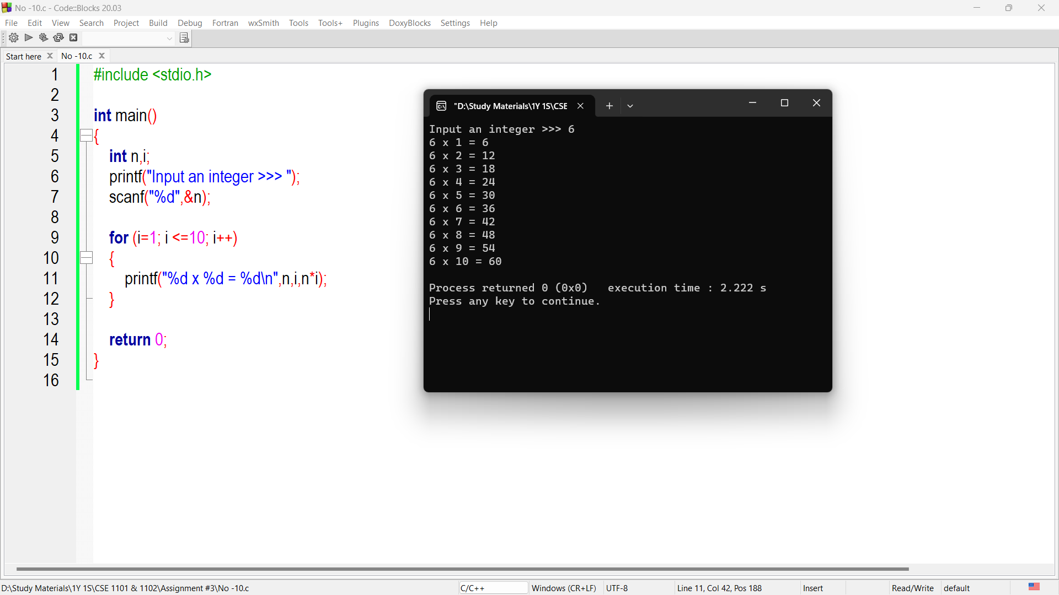

**Problem No – 11**

Write a program in C to make such a pattern like a right angle triangle with the number increased by 1.

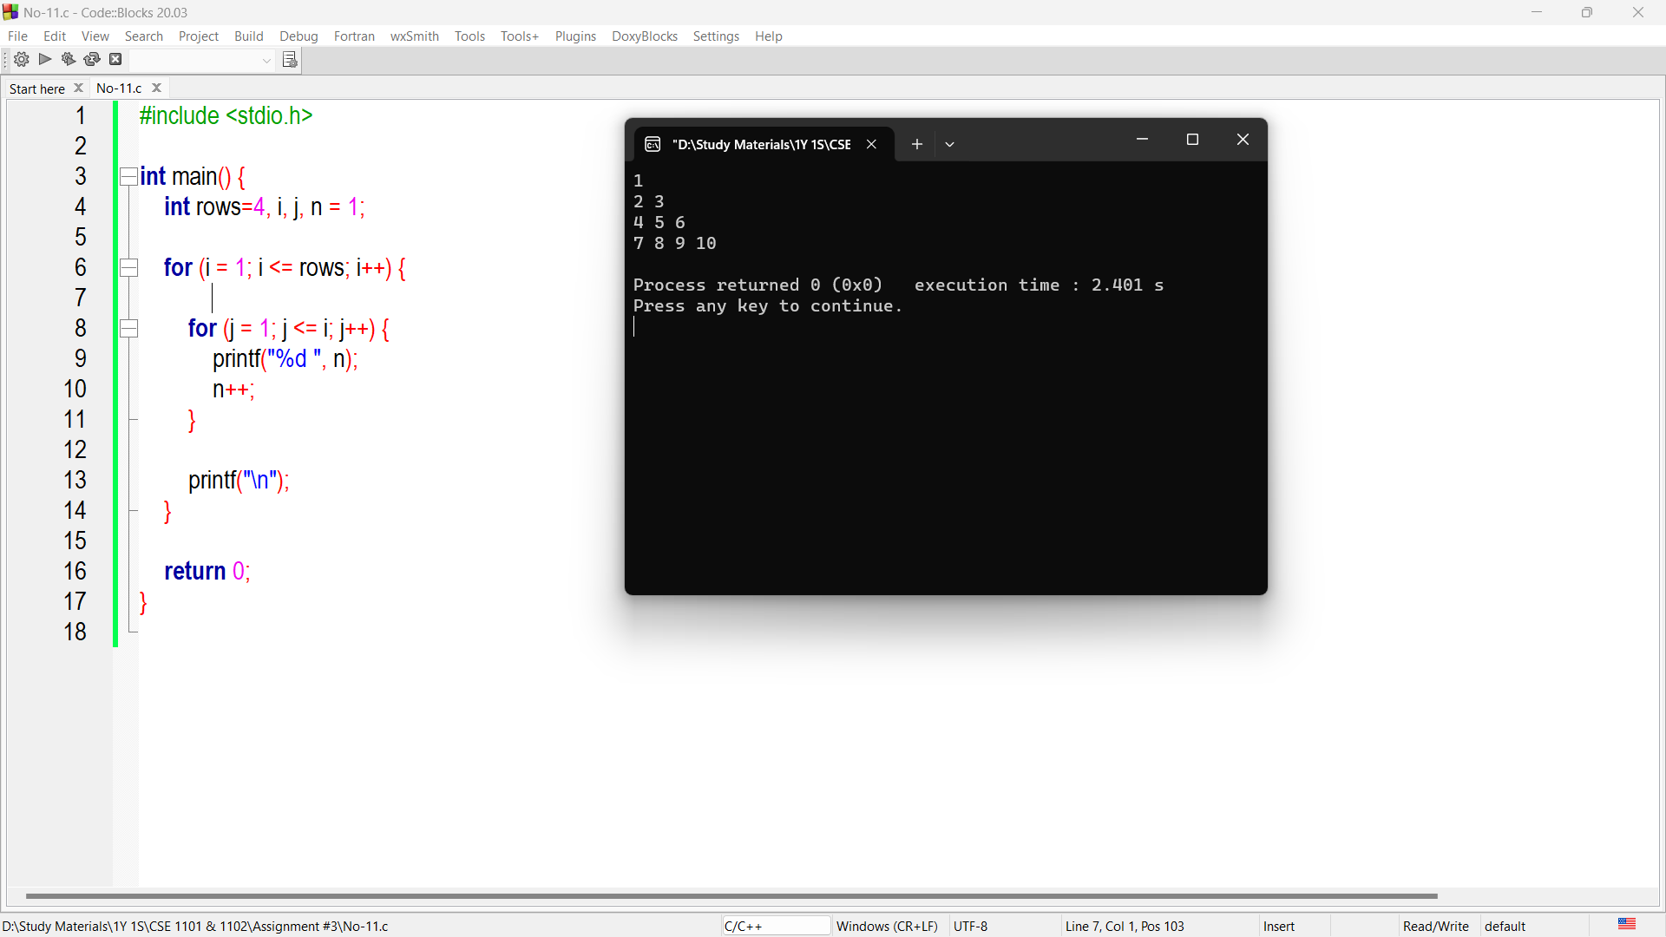

**Problem No – 13**

Write a program in C to find the number and sum of all integers between 100 and 200, which are divisible by 9.

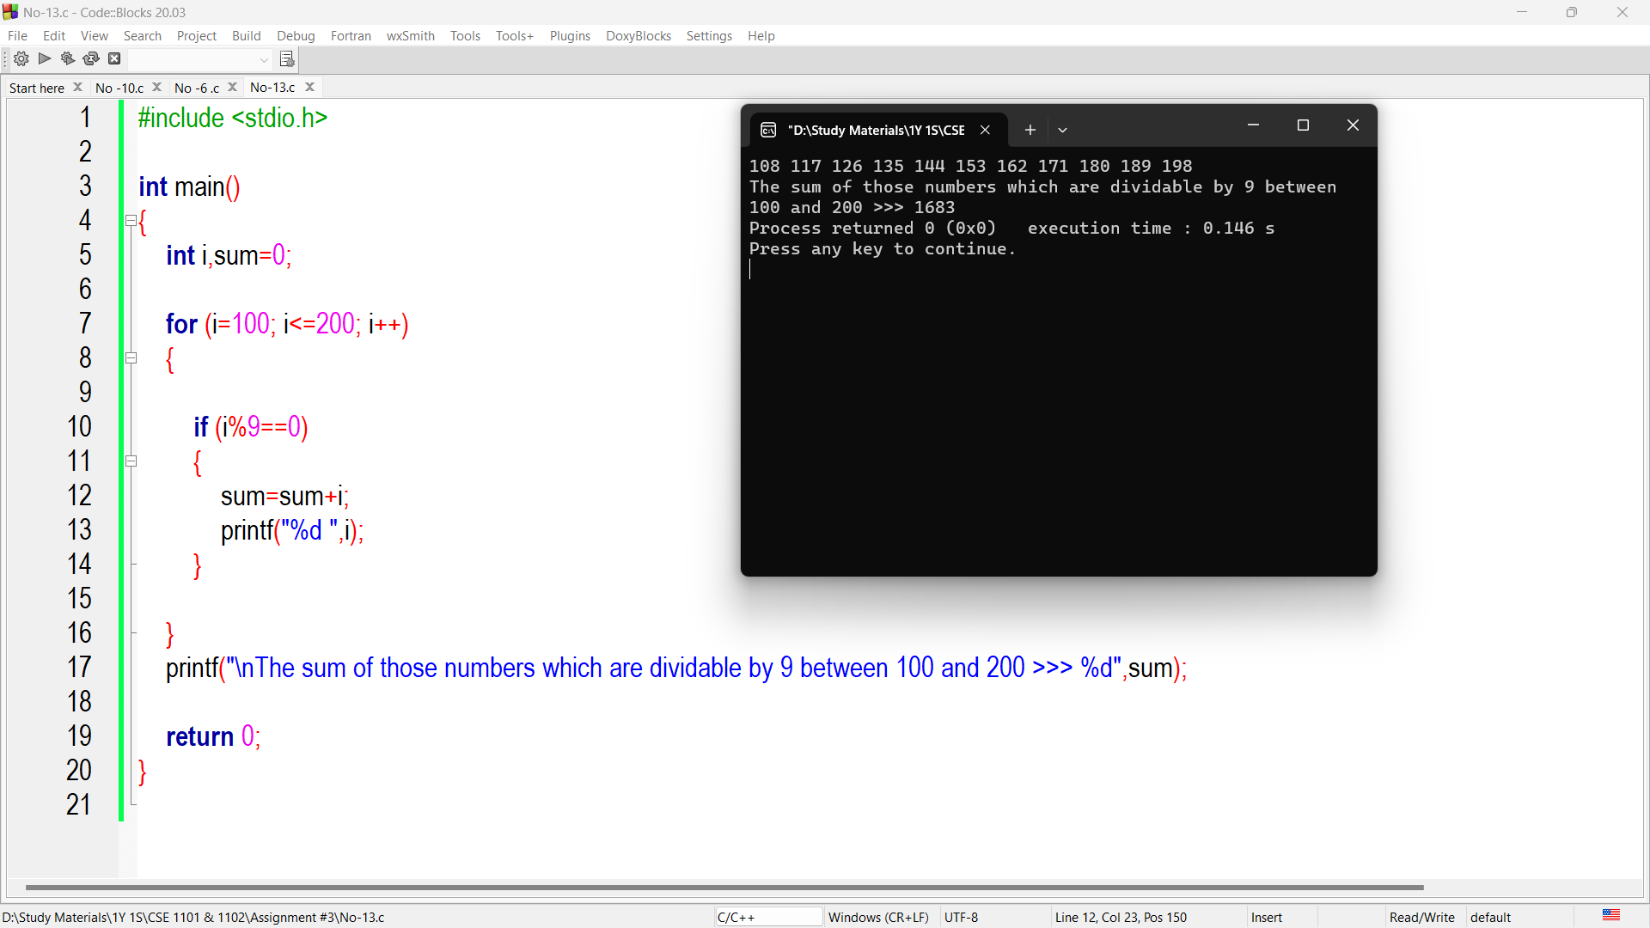

**Problem No – 14**

Write a C program to check whether a number is a Strong Number or not (A strong number is one in which the factorial of each digit of a number equals the original number’s sum).

